- The image below shows a diagram for a 4-point bending test. The beam has height ℎ = 0.004m and depth 𝑏 = 0.01m (not shown in the figure). The length 𝐿 = 0.03m. Determine the force 𝑃 and corresponding normal strain at the middle point of beam surface when the beam starts to yield. Assume E=207GPa, and the yield strength is 1560 MPa.
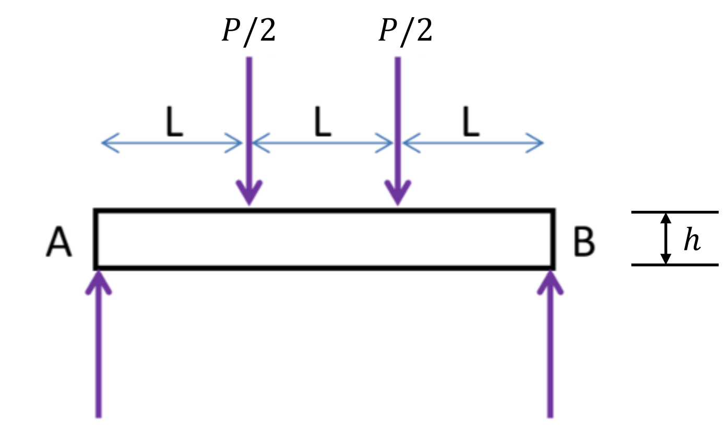
$$Tensile Strength (MPa) =1900$$
$$Yield Strength (MPa) = 1560$$
$$E=207GPa$$
$$σ=\frac{3*P*L}{b*h^{2}}=\frac{3*0.03*P}{0.01*{0.004}^{2}}=1560*{10}^{6} Pa→P=\frac{8320}{3}N≅2773.33N$$
$$σ=E*ϵ→1560*10^{6}=207*{10}^{9}Pa*ϵ→ϵ={\frac{13}{1725}m}/m≅{0.0075362318841 m}/{m }$$

- Composite design: A composite is made from unidirectional strands of fibers in a polyester matrix. If the ultimate tensile strength and modulus of elasticity of a composite should be at least 1.2 GPa and 50 GPa, respectively, what is the requirement of tensile strength and modulus of elasticity of the reinforcement fibers? List all possible reinforcement materials you can use from Table 2-19 in the textbook that fulfill these requirements simultaneously. Assume the volume fraction of fibers is 30%. Use material data from Table 2-19.
$$V_{f}=30\%, and V_{m}=70\%, σ_{uc}=1.2 GPa, E_{c}=50 GPa, E_{m}=2.76 GPa$$
$$σ_{uc}=σ_{uf}V_{f}+{σ^{'}}_{m}V_{m}$$
$$E_{c}=E_{f}V_{f}+E_{m}V_{m}$$
$$ε_{f}=\frac{σ_{uf}}{E_{f}}$$
$${σ'}_{m}=E_{m}ε_{f}=E_{m}*\frac{σ_{uf}}{E_{f}}→{σ^{'}}_{m}=2.76*\frac{σ_{uf}}{\left(\frac{12017}{75}\right)}$$
$$50GPa=E_{f}*0.3+2.76GPa*0.7→E_{f}=\frac{12017}{75}GPa=160.2266GPa$$
$$1.2GPa=σ_{uf}0.3+{σ^{'}}_{m}0.7$$
Solving system of Equations
$${σ^{'}}_{m}=2.76*\frac{σ_{uf}}{\left(\frac{12017}{75}\right)}→σ_{uf}=\frac{12017}{207}*{σ^{'}}_{m}$$
$$1.2GPa=σ_{uf}0.3+{σ^{'}}_{m}0.7→σ_{uf}=-\frac{7}{3}*{σ^{'}}_{m}+4$$
$$σ_{uf}=\frac{12017}{3125}GPa≅3845.44MPa$$
$${σ'}_{m}=\frac{207}{3125}GPa≅66.24MPa$$
Possible Reinforcement Materials:
After Consulting Table 2-19, ONLY Carbon-PAN (high-strength) fulfills the requirements of 3,845MPa Tensile strength and 160.2GPa Elastic Modulus

- Shaft design under torsion: A hollow rectangular steel tube (see cross-section in Figure 3-10) has outside dimensions of 4.00 by 2.00 inch and a wall thickness of 0.109 inch. Compute the maximum torque that can be applied to such a tube if the shear stress is to be limited to 6000 psi. For this torque, also compute the angle of twist of the tube over a length of 6.5 ft. Assume the tube material is 18-8 (304) stainless steel with modulus of elasticity 28×10^6 psi. Hint: you need to use material property relationship Eq. (2-5) and Poisson’s ratio to be found in Table 2-1 in the textbook.
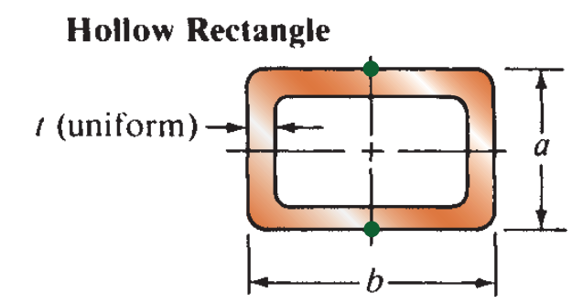
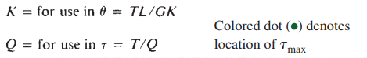
$$K=\frac{2t{\left(a-t\right)}^{2}{\left(b-t\right)}^{2}}{a+b-2t}$$
$$Q=2t(a-t)(b-t)$$
EQ 2.5: $G=\frac{E}{2(1+v)}$
V=0.3
Find T if τ_max =6000psi
For Torque T, find the angle of twist
$$6000=\frac{T}{2*0.109(2-0.109)(4-0.109)}→T=\frac{2406027087}{250000}≅9624.108 lb*in$$
$$θ=\frac{\frac{2406027087}{250000}*6.5ft*12\frac{in}{ft} }{\frac{28*{10}^{6}}{2(1+0.3)}*\frac{2*0.109{\left(2-0.109\right)}^{2}{\left(4-0.109\right)}^{2}}{2+4-2*0.109}}=\frac{418782}{12263135}≅0.03415 rad$$

- Beam design under bending: From Table 15-11 in Appendix 15 in the textbook, select a smallest possible cross-section for an aluminum I-beam shape to carry the load shown below with a maximum normal stress of 12,000 psi. The cross-section of the I-beam is shown at the bottom and the bending is along the X-X axis.
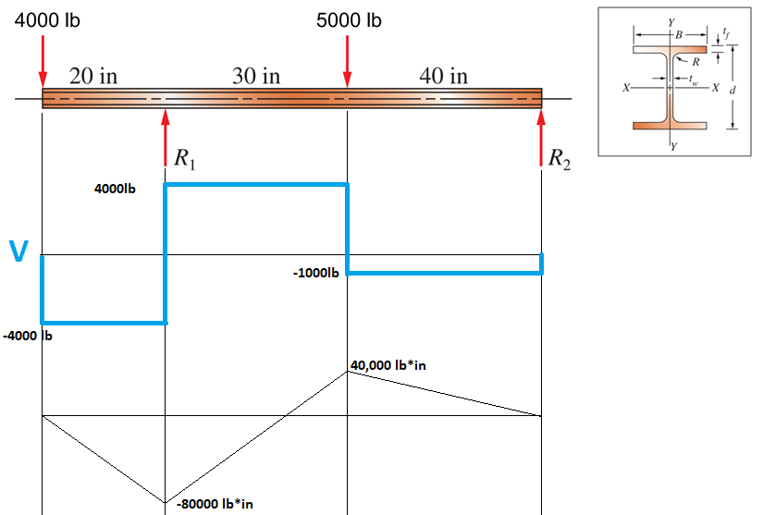
Let’s create the moment and shear diagram.
$$R_{1}+R_{2}=9000lb$$
$$R_{1}*70in=5000*40in+4000*90in→R_{1}=8000lb$$
$$R_{2}=1000lb$$
$$σ=\frac{M_{max} }{S}$$
$$12000=\frac{80000}{S}→S has to be\frac{20}{3}≅6.66 or larger.$$
After Consulting Table 15-11 from Mott, R., Vavrek, E., & Wang, J. (2017). Machine Elements in Mechanical Design (6th ed.). Pearson, sourced from “Aluminum Association, Aluminum Standards and Data, 11th ed., Washington, DC, © 1993, p. 187”, It can thus be determined that an aluminium I-Beam with the specifications listed below shall meet the prerequisite requirements as set above, not accounting for any manufacturing, transportation, or any other form of defect.
Depth(in.) | Width(in.) | Area(in.²) | Weight (lb/ft) | Flange thickness(in.) | Web Thickness (in.) | Fillet Radius(in.)
6.00 | 4.00 | 3.427 | 4.030 | 0.29 | 0.19 | 0.3

- Beam design under combined loadings 1: Determine the minimum diameter of the main shaft portion, labeled A, B, and C, by considering both shear and tensile strength. Include any unbalanced torque on the shaft that tends to rotate it about the z-axis. Draw the complete shearing force and bending moment diagrams for loading in the y-z plane. The shaft material is Aluminum 7075-T6. Find the material property in Appendix 9 in the textbook.
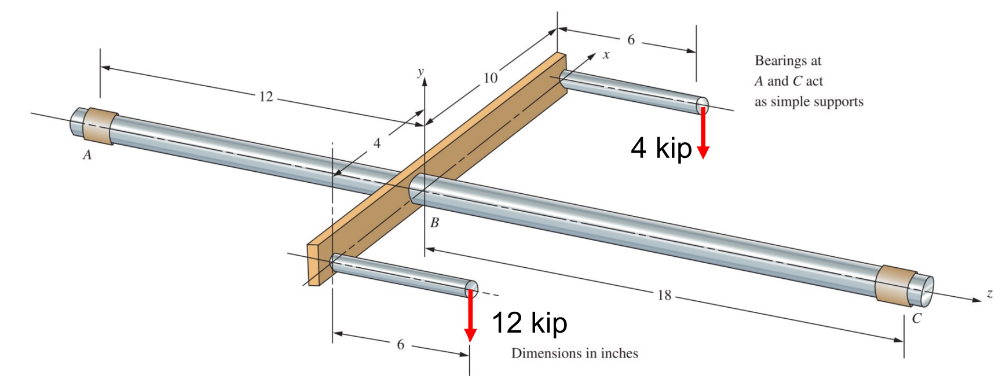
83 ksi tensile
48 ksi shear
$$16000lb*6in=96000lb*in$$
$$T→12000lb*4in-4000lb*10in=8000lb*in(z-axis rotation)$$
$$R_{a}+R_{c}=16kip$$
$$R_{c} *30=16kip*12+96kip*in→R_{c}=9.6 kip$$
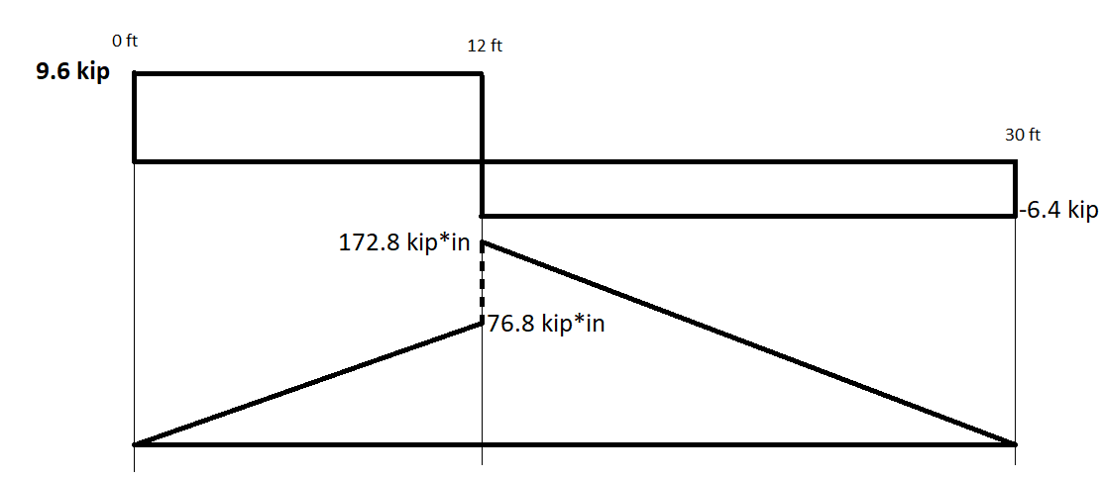
$$S≥\frac{M_{max}}{σ_{d}}=\frac{172.8 kip⋅in}{83 ksi}=\frac{864}{415}≅2.0819277$$
$$S=\frac{πD^{3}}{32}→\frac{πD^{3}}{32}=\frac{864}{415}→D=\frac{24\sqrt[3]{2}}{\sqrt[3]{415π}}≅2.768$$
$$Z_{p}=\frac{πD^{3}}{16}$$
$$τ_{max}=\frac{T}{Z_{p}}→48kip=\frac{8kip}{\frac{πD^{3}}{16}}→D=\frac{2}{\sqrt[3]{3π}}≅0.9468$$
Thus, Because the Diameter found using Shear strength is larger than the diameter found using Tensile stress, it may be assumed that the minimum diameter must be 2.768 inches or larger.

- Beam design under combined loadings 2: Determine the minimum thickness of the lever at position A, by only considering the tensile strength of the lever. The lever material is Cast Iron Gray iron-ASTM A48 No. 60A. Find the standard value of the ultimate strength (σ_{u}) in Appendix in the textbook. The cross-section is rectangular with height 𝐻 = 50 mm at position A and bending happens along XX-axis.
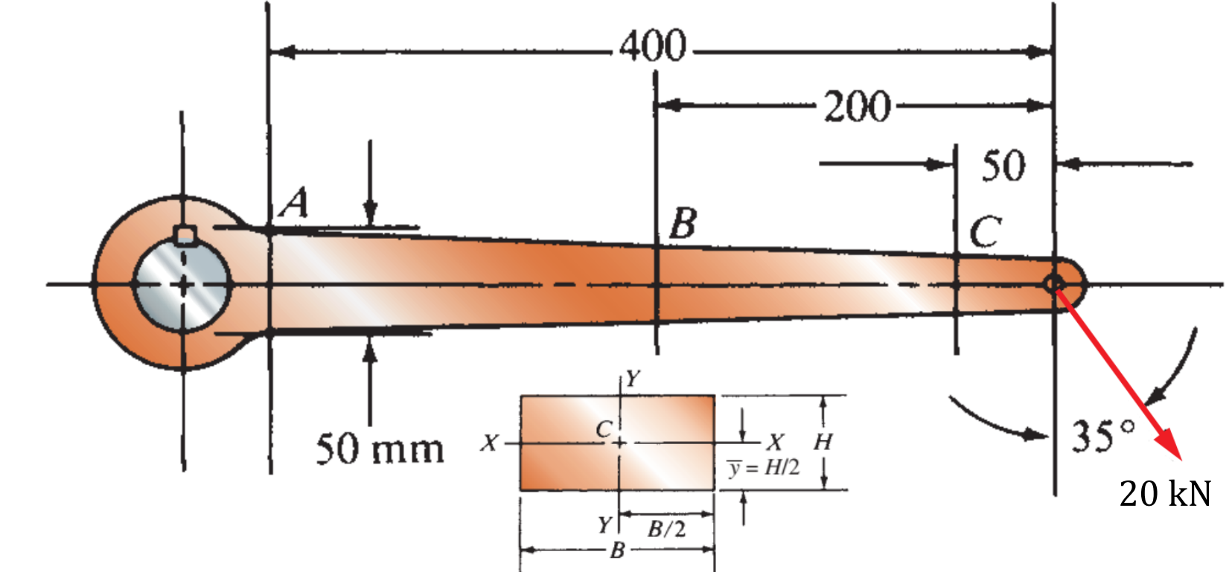
$$σ_{u}=414 MPa$$
$$E=148GPa$$
$$F_{x}=20*\sin\left(35°\right)≅11.4715287270209kN$$
$$F_{y}=20*\cos\left(35°\right)≅16.3830408857798kN$$
$$N=F_{x}=20000sin\left(35°\right)$$
$$M=F_{y}*0.4m=0.4*20000\cos\left(35°\right)=8000cos⁡(35°)$$
$$σ_{max}=\frac{N}{A}+\frac{M}{S_{A}}→414*{10}^{6}=\frac{20000\sin\left(35°\right)}{0.05*B}+\frac{8000\cos\left(35°\right)}{\frac{B*{0.05}^{2}}{6}}→B≅0.0385438m=38.54mm$$

- Mohr’s circle for combined loadings 1: A solid steel shaft with diameter of 1.5 in is simply supported at the ends. Two pulleys are keyed to the shaft where pulley B is of diameter 4.0 in and pulley C is of diameter 8.0 in. Considering bending and torsional stresses only, determine the maximum tensile stress and absolute maximum shear stress on a surface point E just right to the point B. Hint: The net maximum moment does not necessarily occur along y- or z-direction.
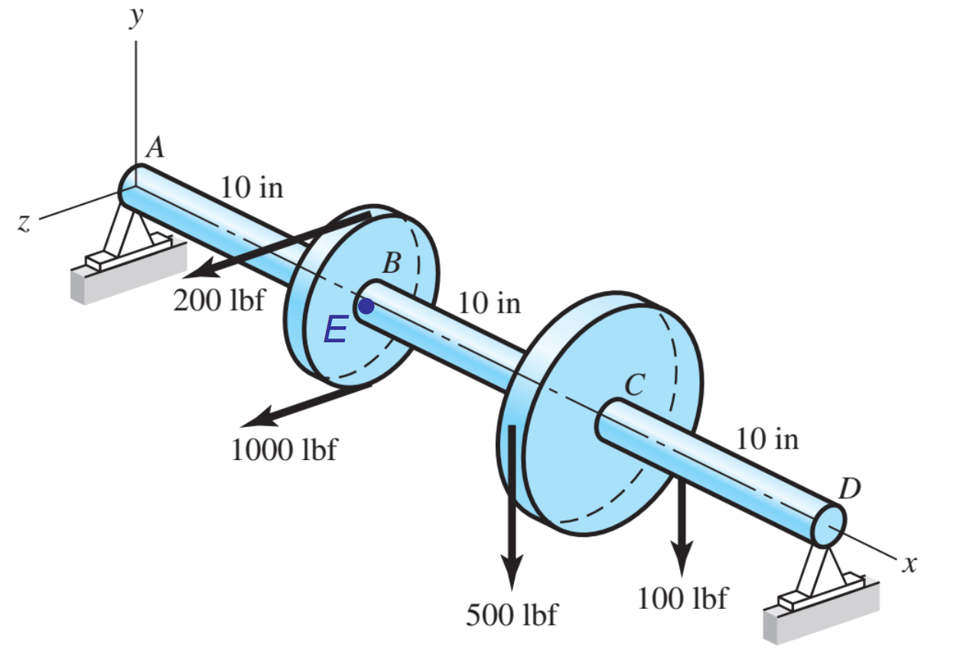
$$1200lbf in the z direction, 600lbf in the y direction$$
$$R_{A-Z}→1200lbf*20in-R_{A-Z}*30in=0→800lbf$$
$$R_{D-Z}→1200-800=400lbf$$
$$R_{A-Y}=30*R_{A-Y}-600*10→R_{A-Y}=200lbf$$
$$R_{D-Y}→600-200=400lbf$$

$$Torque in the X axis: ↻(800 lbf*2in)+↺(400lbf*4in)=0 Total Torque$$
$$M_{C}=\sqrt{{4000}^{2}+{4000}^{2}}≅5656.85 lbf⋅in$$
$$M_{B}=\sqrt{{2000}^{2}+{8000}^{2}}=2000\sqrt{17}≅8246.2 lbf⋅in$$
Max Moment: 8246.2 lbf⋅in
$$σ_{x}=\frac{M}{S}=\frac{2000\sqrt{17}}{\frac{π{1.5}^{3}}{32}}=\frac{512000\sqrt{17}}{27π}≅24887.472\frac{lbf}{in^{2}}$$
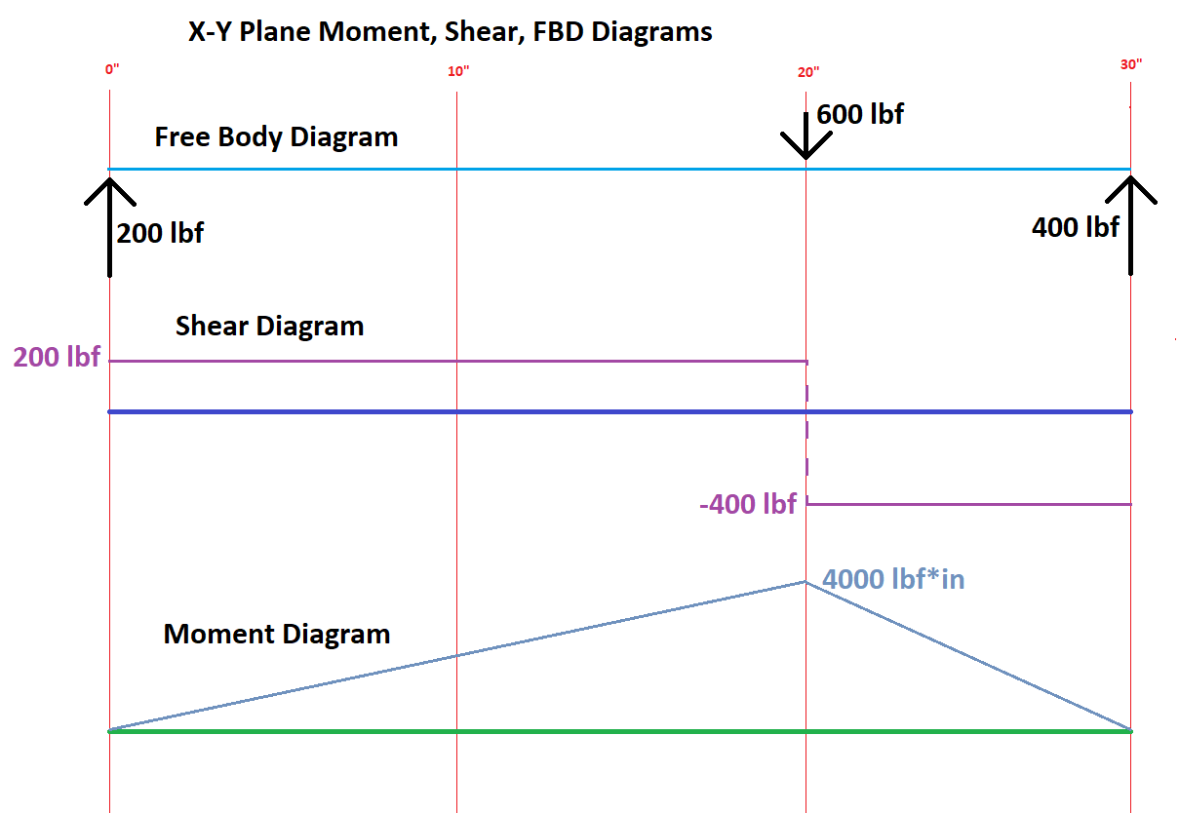
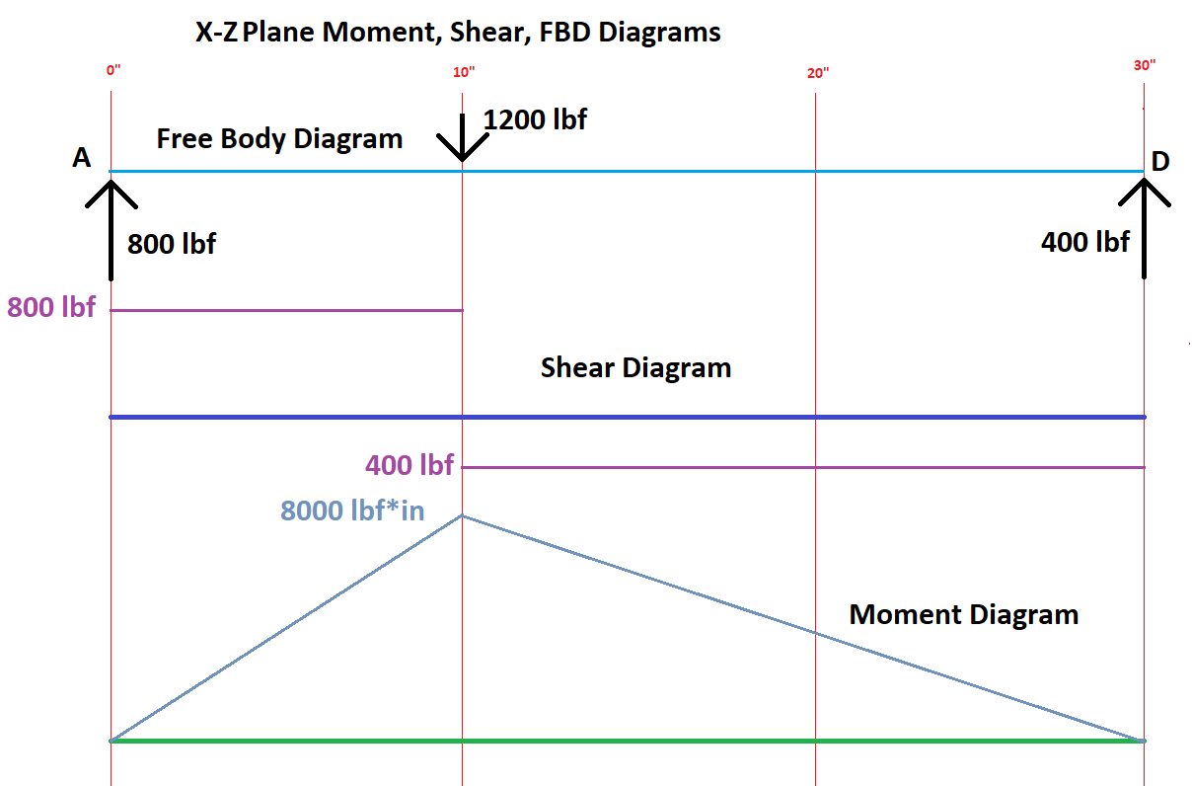

$$τ_{xy}=\frac{T}{Z_{p}}=\frac{1600lbf⋅in}{\frac{π{1.5}^{3}}{16}}=\frac{204800}{27π}≅2414.44\frac{lbf}{in^{2}}$$
$$σ_{1}=\frac{σ}{2}+\sqrt{{\left(\frac{σ}{2}\right)}^{2}+τ_{xy}^{2}}=\frac{\frac{512000\sqrt{17}}{27π}}{2}+\sqrt{{\left(\frac{\frac{512000\sqrt{17}}{27π}}{2}\right)}^{2}+{\left(\frac{204800}{27π}\right)}^{2}}≅25119.543\frac{lbf}{in^{2}}$$
$$σ_{2}=\frac{σ}{2}-\sqrt{{\left(\frac{σ}{2}\right)}^{2}+τ_{xy}^{2}}=\frac{\frac{512000\sqrt{17}}{27π}}{2}-\sqrt{{\left(\frac{\frac{512000\sqrt{17}}{27π}}{2}\right)}^{2}+{\left(\frac{204800}{27π}\right)}^{2}}≅-232.07 \frac{lbf}{in^{2}}$$
$$absolute maximum shear stress: τ_{max}=\frac{σ_{1}-σ_{2}}{2}=\frac{2R}{2}=\frac{2*\left(\sqrt{{\left(\frac{\frac{512000\sqrt{17}}{27π}}{2}\right)}^{2}+{\left(\frac{204800}{27π}\right)}^{2}}\right) }{2}=\frac{358400}{9π}≅12675.807\frac{lbf}{in^{2}}$$

- Mohr’s circle for combined loadings 2: For the shaft ABC, draw the Mohr’s circle to determine the principal stresses and absolute maximum shear stress for a point on the bottom of the shaft just to the right of section B. The torque applied to the shaft at B is resisted at support C only. The shaft diameter is 38 mm.
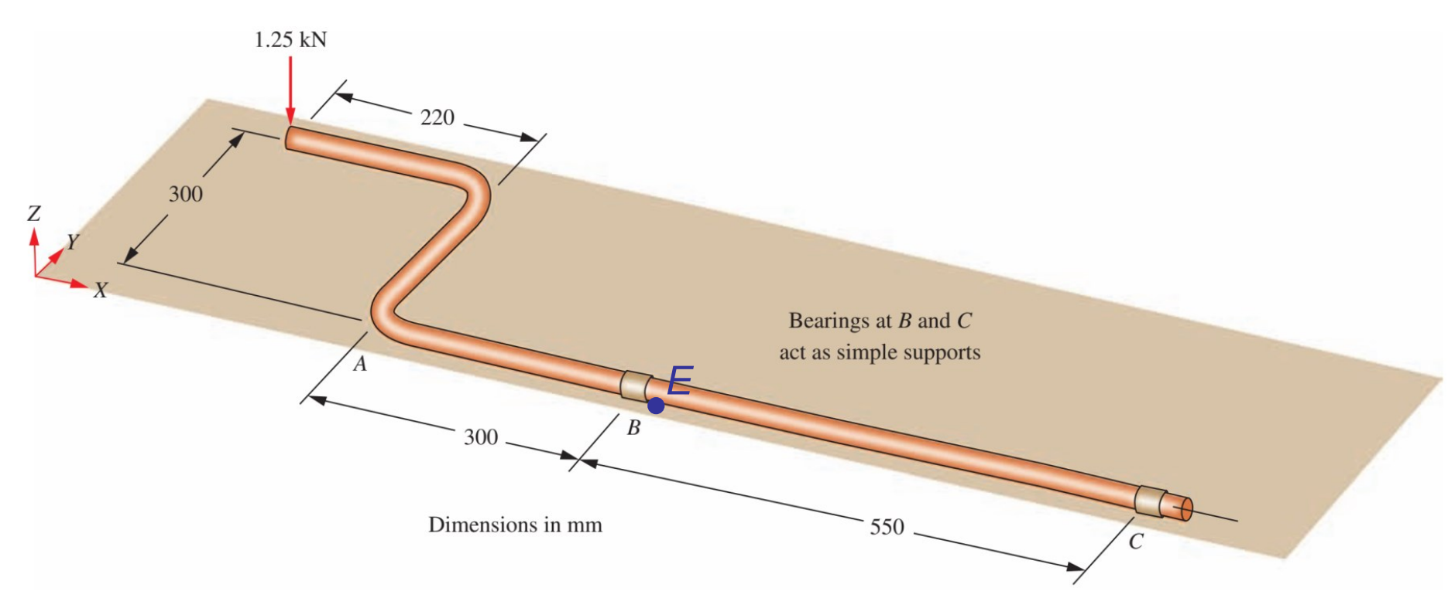
$$Torque(X axis) = 1250N*0.3m=375N*m$$
$$Moment=\left(1250N*0.22m\right)=275N*m$$
$$R_{B}*0.55=1250*0.85+275→R_{B}=\frac{26750}{11}≅2431.8N$$
$$R_{B}+R_{C}=1250N→1250-\frac{26750}{11}=R_{C}=-\frac{13000}{11}≅-1818N$$
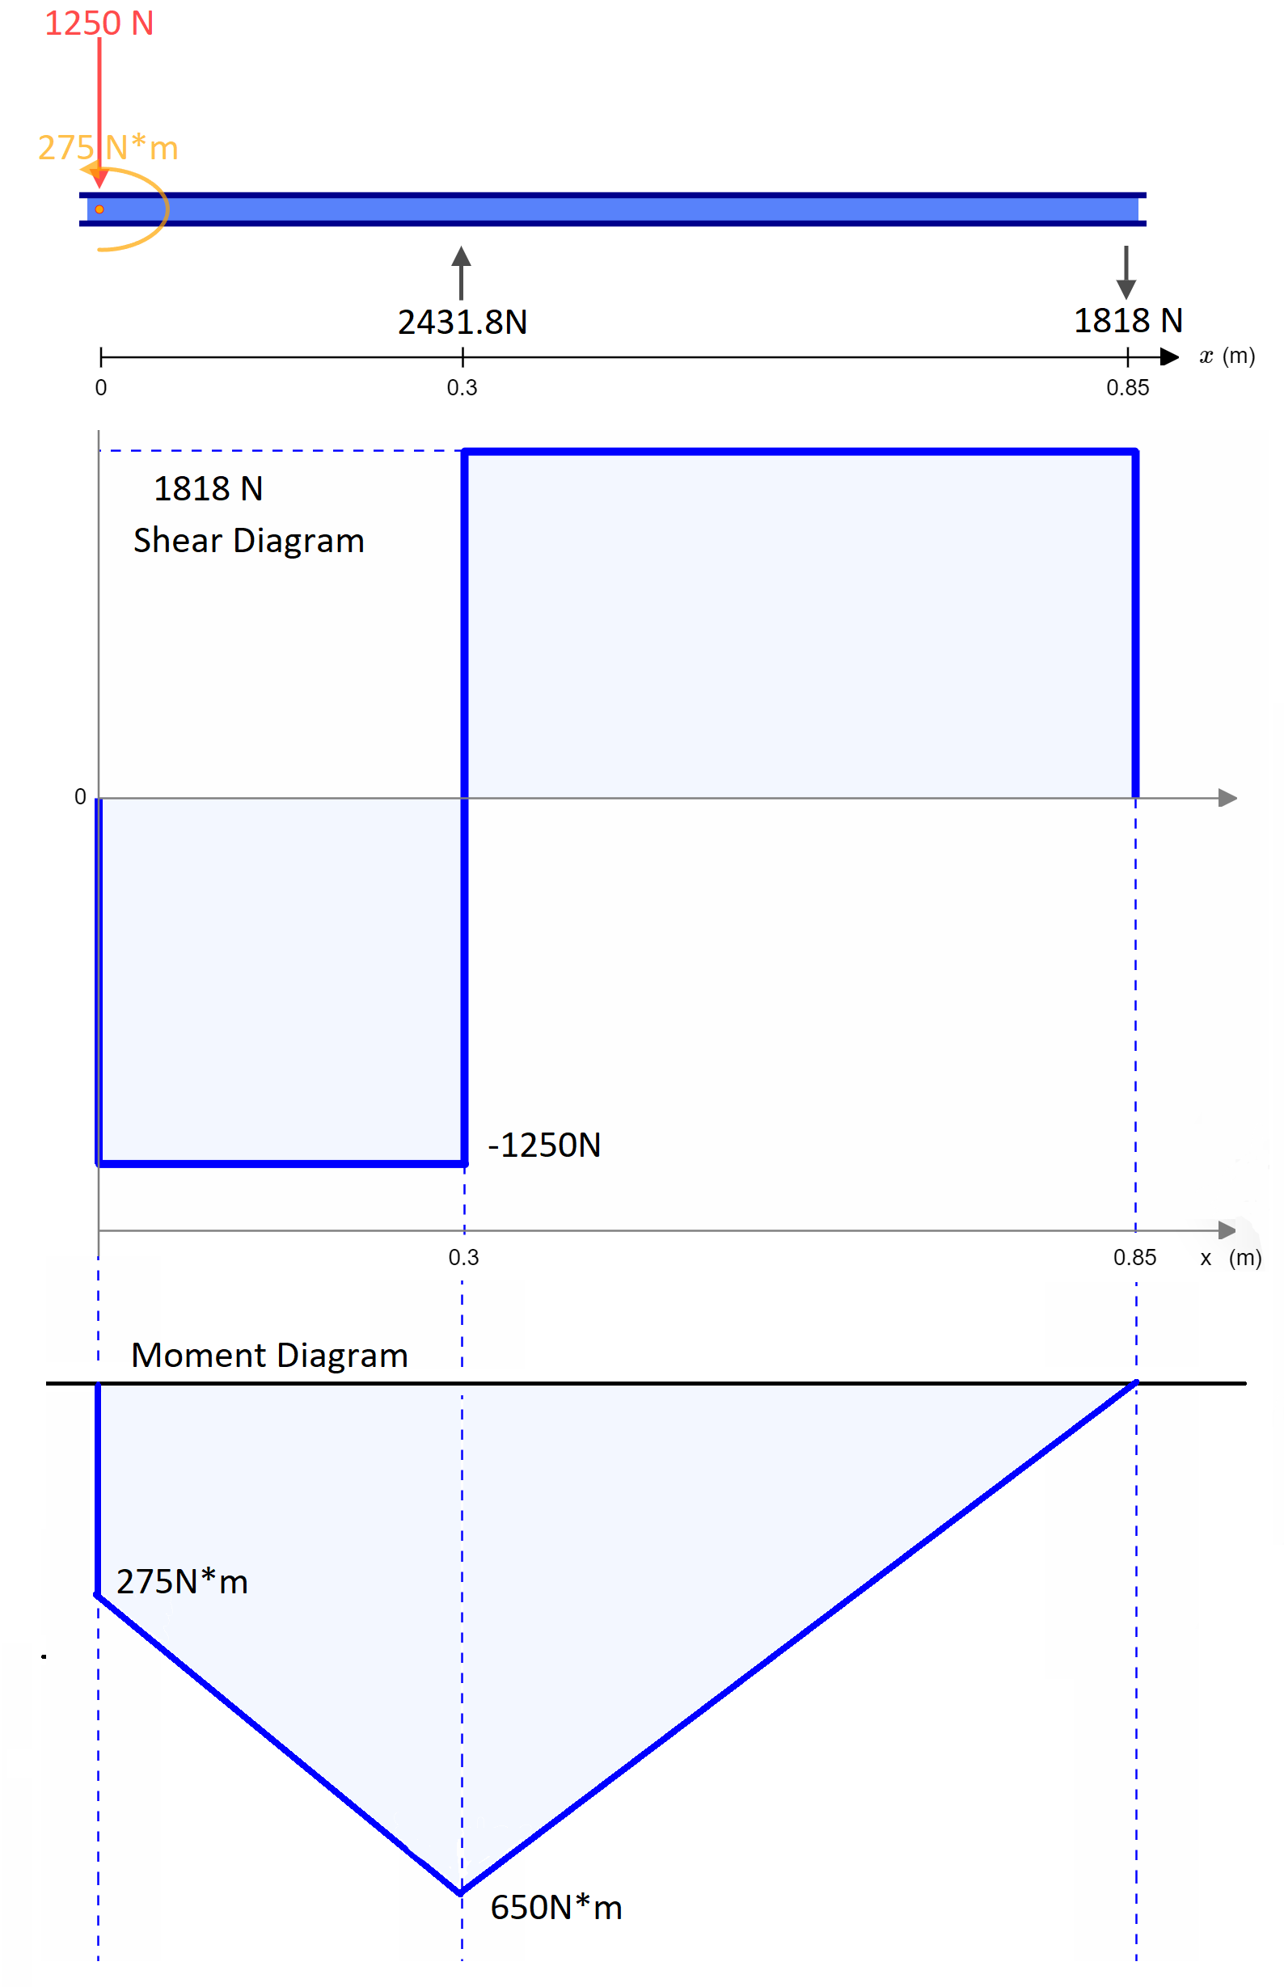
$$σ_{x}=\frac{M}{S}=\frac{650}{\frac{π{0.038}^{3}}{32}}=\frac{2600000000000}{6859π}≅120.66MPa$$
$$τ_{xy}=\frac{T}{Z_{p}}=\frac{375}{\frac{π{0.038}^{3}}{16}}=\frac{750000000000}{6859π}≅34.805MPa$$
$$σ_{1}=\frac{σ}{2}+\sqrt{{\left(\frac{σ}{2}\right)}^{2}+τ_{xy}^{2}}=\frac{\frac{2600000000000}{6859π}}{2}+\sqrt{{\left(\frac{\frac{2600000000000}{6859π}}{2}\right)}^{2}+{\left(\frac{750000000000}{6859π}\right)}^{2}}≅129980006.69Pa→129.98MPa$$
$$σ_{2}=\frac{σ}{2}-\sqrt{{\left(\frac{σ}{2}\right)}^{2}+τ_{xy}^{2}}=\frac{\frac{2600000000000}{6859π}}{2}-\sqrt{{\left(\frac{\frac{2600000000000}{6859π}}{2}\right)}^{2}+{\left(\frac{750000000000}{6859π}\right)}^{2}}≅-9320186.88Pa→-9.32MPa$$
$$τ_{max}=\frac{σ_{1}-σ_{2}}{2}=\frac{2R}{2}=\frac{2*\left(\sqrt{{\left(\frac{\frac{2600000000000}{6859π}}{2}\right)}^{2}+{\left(\frac{750000000000}{6859π}\right)}^{2}}\right) }{2}=\frac{50000000000\sqrt{901}}{6859π}≅69650096.79Pa→69.65MPa$$

